**Car Rental Management System Report**

Name: Umut Eren KEIYINCI

Student Number:17578815226

Introduction

The Car Rental Management System is a Java-based application designed to manage the renting of cars to customers. The system provides functionality for adding new cars and customers, displaying available cars for rent, renting cars to customers, displaying customer details, managing rental details, and more.

Features:

Adding New Cars: Allows users to add new cars to the system with details such as name, brand, license plate number, rent price per day, cost price, and color.

Adding New Customers: Provides functionality for adding new customers with details including name, age, license number, and national ID number.

Displaying Cars and Customers: Allows users to view all cars and customers stored in the system.

Renting Cars: Enables users to rent cars to customers for a specified number of days.

Managing Rental Details: Provides options for displaying rent details of a customer, releasing a rented car from a customer, and viewing all rents.

Modifying Car Details: Allows users to modify details of existing cars, including color, price, license plate number, and more.

Removing Cars and Customers: Provides functionality for removing cars and customers from the system.

Searching Cars by Name or Brand: Enables users to search for cars by name or brand.

Implementation

The system is implemented using object-oriented programming principles in Java. It consists of four main classes:

Main: Contains the main method and handles user interactions through a console-based menu system.

Controller: Manages the business logic of the system, including adding, removing, and modifying cars and customers, as well as handling rental operations.

Car: Represents a car object with properties such as name, brand, license plate number, rent price per day, cost price, color, and rental details.

Customer: Represents a customer object with properties including name, age, license number, national ID number, and rented cars.

**EXAMPLE ASSERTION CASE TEST**

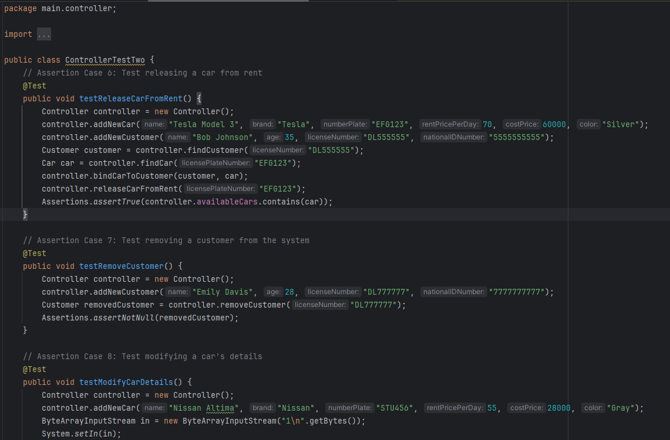

**THE UML DIAGRAM OF CAR RENTAL MANAGEMENT SYSTEM REPORT**

